1. **Our Solution**

We propose to develop a simulation model of the Mars landing process that can be used to train an autonomous system that can handle any unexpected situations on its own, increasing the probability of safe landing and decreasing the uncertainty of the location of landing. Resulting in safer, more accurate location landing. The model will be built using classical control algorithms and attempts to use artificial intelligence (AI) techniques [16].   
The classical control algorithms will be used to design a guidance, navigation, and control (GNC) system for the spacecraft. The GNC system will be responsible for determining the spacecraft’s attitude, velocity, and position, and for generating the necessary control commands to ensure that the spacecraft lands safely on Mars [3]. The AI techniques will be used to develop a system that can identify and avoid hazards, such as steep slopes and large rocks, and to navigate to the optimal landing spot. The system will be trained using a simulator that can generate realistic scenarios of Mars landing [19]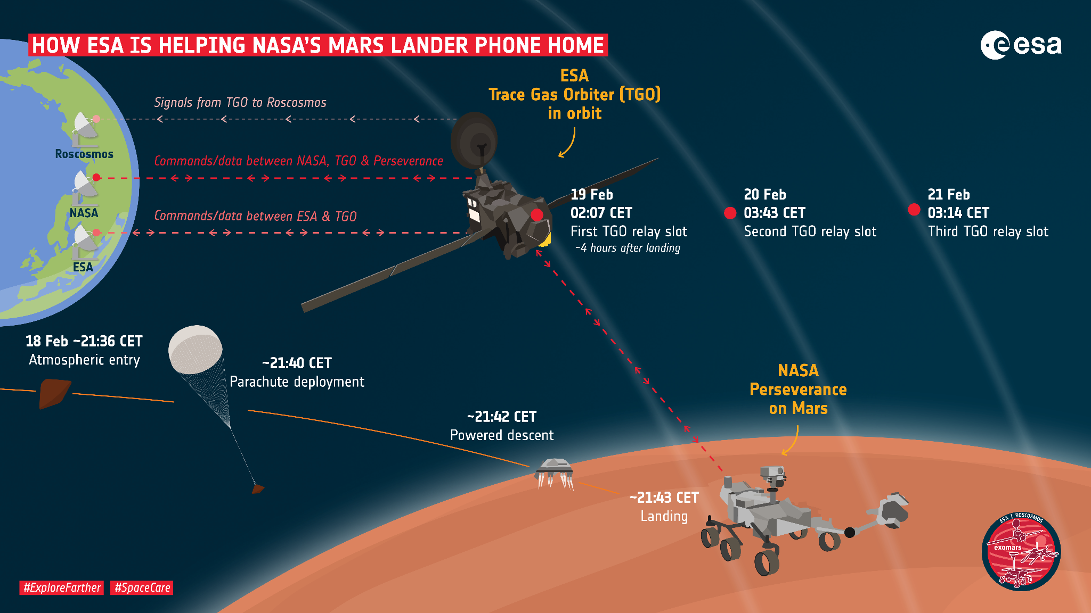

1. **Objectives**

* To develop a simulation model of the Mars landing process that can be used to train an autonomous system that can handle any unexpected situations on its own.[8]
* To use classical control algorithms and artificial intelligence techniques to design a guidance, navigation, and control system for the spacecraft.[3]
* To increase the probability of safe landing and decrease the uncertainty of the location of landing.[2]
* To identify and avoid hazards, and navigate to the optimal landing spot.[19]
* To contribute to the field of autonomous spacecraft landing by making it more robust, efficient, and flexible.[16]

1. **The proposed solution**has several advantages over existing methods.

* It is more robust to unexpected situations, as the AI system can learn to adapt to new scenarios.[2]
* It is more efficient, as the AI system can optimize the landing process to minimize fuel consumption and landing time.[7]
* It is more flexible, as the AI system can be easily reprogrammed to handle different missions and landing conditions[16]
* It can result in higher landing accuracy.[17]

1. **Implementation**

The proposed solution will be implemented in the following steps:

1. **Simulation Model Development:** Develop a simulation model of the Mars landing process.
   * The model will include the spacecraft dynamics, the Martian environment, and the sensors that will be used to control the spacecraft. [8, 9, 11]
   * GUI that visualizes the landing process
2. **Classical Control GNC System Design**: Design a classical control GNC system for the spacecraft.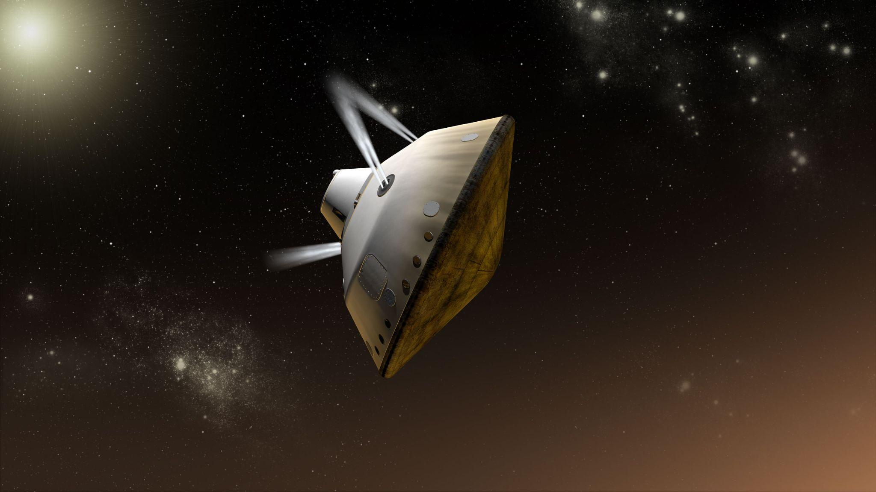
   * The GNC system will be responsible for determining the spacecraft's attitude, velocity, and position, and for generating the necessary control commands to ensure that the spacecraft lands safely on Mars. [3, 4, 17]
3. **AI System Development**: Attempt to develop an AI system that will be trained using the simulation model, the AI will be trained to
   * Increase the probability of safe landing [15]
   * Decrease the uncertainty of the location of landing [12,15]
   * and as a backup plan Identify and avoid hazards and navigate to the optimal landing spot.[14]
4. **Integration of Control Systems**:Integrate the classical control GNC system and the AI system into a single system.
   * The integrated system will be responsible for controlling the spacecraft during the landing process.
5. **Test and evaluate** the integrated system using the simulation model.[5,20]

**D. Expected Outcomes**

The expected outcomes of the project are:

* A simulation model of the Mars landing process that can be used to train an autonomous system that can handle any unexpected situations on its own.
* A simulation model GUI that can be used to visualize the Mars landing process.
* A classical control GNC Algorithms system for the spacecraft.
* An integrated system that can autonomously control the spacecraft during the landing process.
* A report documenting the design, implementation, and evaluation of the system.
* A conclusion about using AI in GNC.
* A presentation explaining the system's performance and capabilities.  
    
  This solution is expected to contribute to the field of autonomous spacecraft landing.

**2. Methodology:**

1. **Project Initiation:**   
   a. Formulation of the project team, including experts in aerospace engineering, control systems, and artificial intelligence.   
   b. Define project goals, scope, and constraints.   
   c. Allocate resources, budget, and timeline for the project.
2. **Literature Review:**   
   a. Conduct a comprehensive review of existing Mars landing methods, GNC systems, and AI applications in aerospace. [2, 6, 10]   
   b. Identify gaps and challenges in current approaches. [2, 6, 10]   
   c. Analyze relevant classical control algorithms and AI techniques applicable to spacecraft GNC. [3, 4, 7]
3. **Requirements Analysis:**   
   a. Define the functional and non-functional requirements for the simulation model.   
   b. Identify spacecraft dynamics, environmental factors on Mars, and sensor specifications. [8, 9, 11]   
   c. Determine the criteria for safe landing and hazard avoidance. [8, 9, 11]
4. **Simulation Model Development:**  
   a. Create a detailed simulation model that incorporates spacecraft dynamics, Martian environmental factors, and sensor interactions. [8, 9, 11]   
   b. Implement a graphical user interface (GUI) for visualizing the Mars landing process.   
   c. Validate the model against known data and ensure realistic representation of Mars conditions. [8, 9, 11]
5. **Classical Control GNC System Design:**   
   a. Select appropriate classical control algorithms for spacecraft guidance, navigation, and control. [3, 4, 6]   
   b. Develop mathematical models for attitude, velocity, and position determination. [3, 4, 5, 17]   
   c. Implement control algorithms for generating commands to ensure safe landing. [3, 4, 5]

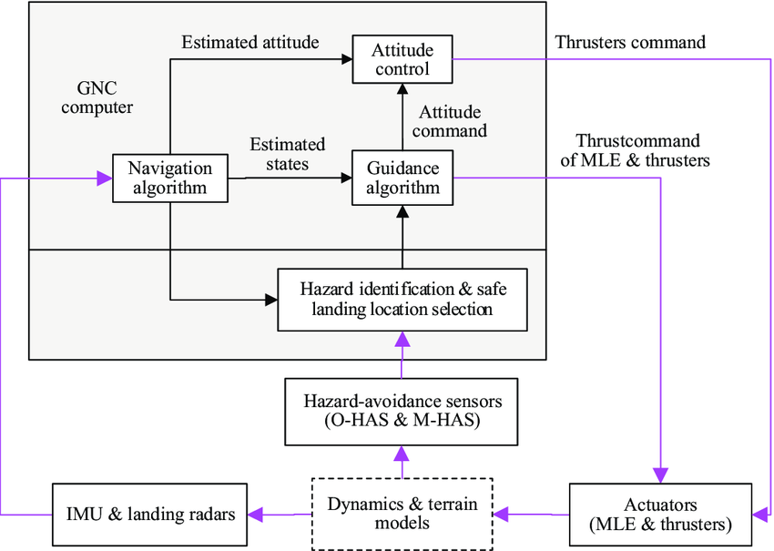

1. **AI System Development:**   
   a. Explore AI techniques suitable to improve GNC algorithms. [2, 16]   
   b. Develop an AI training pipeline using the simulation model, focusing on increasing landing safety and reducing location uncertainty. [7, 16, 13]   
   c. Implement backup plans for hazard avoidance using AI if needed. [11,14]
2. **Integration of Control Systems:**   
   a. Establish communication protocols between the classical control GNC system and the AI system.   
   b. Develop an integrated control system that seamlessly combines classical control and AI elements. [7]   
   c. Ensure compatibility and reliability of the integrated system. [7, 19,15]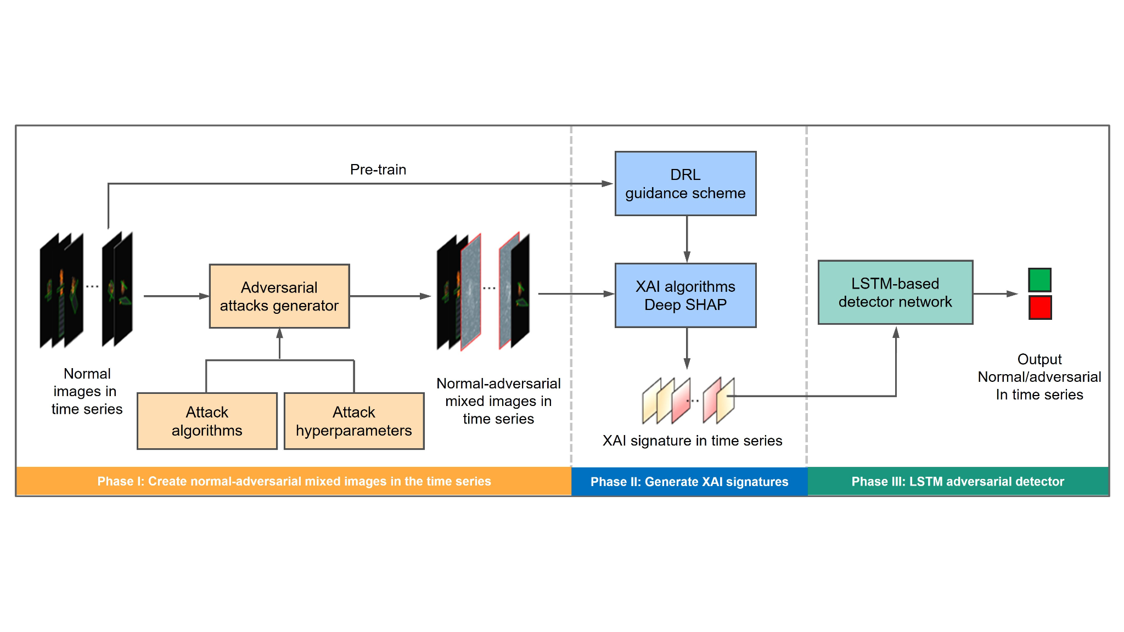
3. **Testing and Evaluation:**   
   a. Conduct extensive testing using the simulation model to evaluate the integrated system’s performance under various scenarios. [15, 12]  
   b. Assess the system’s ability to handle unexpected situations, avoid hazards, and reach optimal landing locations. [19, 16]   
   c. Fine-tune control parameters based on test results. [2, 7, 10]
4. **Documentation:**a. Prepare detailed documentation covering the design, implementation, and testing phases. [1]  
   b. Include information on the simulation model, classical control GNC system, and AI system. [2]  
   c. Provide a performance comparison between the classical way and the modified integrated one. [6]  
   d. Provide code documentation for future reference. [1]
5. **Conclusion and Presentation:**a. Summarize findings and insights from the project. [6]  
   b. Draw conclusions about the effectiveness of integrating AI into GNC for autonomous spacecraft landing. [6]  
   c. Prepare a comprehensive presentation highlighting the system’s performance, capabilities, and potential contributions to autonomous spacecraft landing. [7]
6. **Project Review and Iteration:**  
   a. Conduct a thorough review of the entire project, considering feedback from stakeholders and test outcomes. [1]  
   b. Identify areas for improvement and potential enhancements. [6]  
   c. Iterate on the project to address any shortcomings and enhance system capabilities. [6]

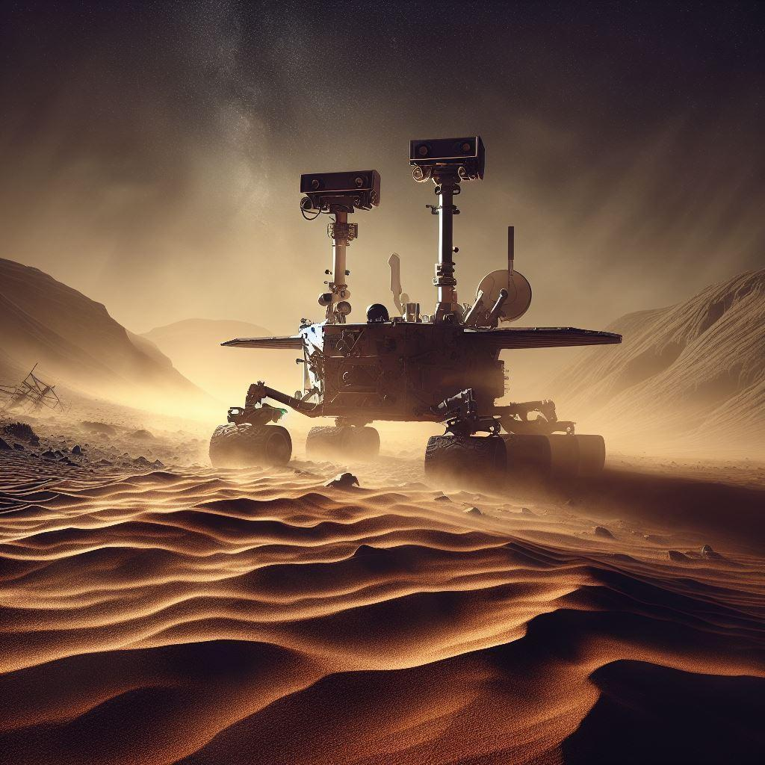

**3. References**

1. Abbeel, P., & Ng, A. Y. (Year). "Exploration and Apprenticeship Learning in Reinforcement Learning." Proceedings of the International Conference on Machine Learning, Page range.
2. [Adaptive pinpoint and fuel efficient mars landing using reinforcement learning | IEEE Journals & Magazine | IEEE Xplore](https://ieeexplore.ieee.org/abstract/document/7004667)
3. Anderson, B. D. O., & Moore, J. B. (Year). Optimal Control: Linear Quadratic Methods. Prentice-Hall.:
4. Bar-Shalom, Y., Li, X. R., & Kirubarajan, T. (Year). Estimation with Applications to Tracking and Navigation: Theory Algorithms and Software. Wiley.
5. [Deep reinforcement learning for six degree-of-freedom planetary landing - ScienceDirect](https://www.sciencedirect.com/science/article/abs/pii/S0273117719309305)
6. [Design and optimization of navigation and guidance techniques for Mars pinpoint landing: Review and prospect - ScienceDirect](https://www.sciencedirect.com/science/article/abs/pii/S0376042117301082)
7. [DRN500TN1069.pdf (nasa.gov)](https://ntrs.nasa.gov/api/citations/20100021401/downloads/20100021401.pdf)
8. Fossen, T. I. (Year). Handbook of Marine Craft Hydrodynamics and Motion Control. Wiley.
9. [Guidance and Control Design for Powered Descent and Landing on Mars | IEEE Conference Publication | IEEE Xplore](https://ieeexplore.ieee.org/abstract/document/4161334)
10. Hoffman, J. (Year). "Mars Environmental Factors Impacting Landing: An Analysis." Journal of Planetary Sciences, Volume(Issue), Page range.
11. [Image-based Deep Reinforcement Learning for Autonomous Lunar Landing | AIAA SciTech Forum](https://arc.aiaa.org/doi/abs/10.2514/6.2020-1910)
12. [INTEGRATED GUIDANCE AND CONTROL FOR PINPOINT MARS LANDING USING REINFORCEMENT LEARNING](https://www.researchgate.net/profile/Brian-Gaudet/publication/327537473_Integrated_Guidance_and_Control_for_Pinpoint_Mars_Landing_Using_Reinforcement_Learning/links/5bd0fbb192851cabf265b8a1/Integrated-Guidance-and-Control-for-Pinpoint-Mars-Landing-Using-Reinforcement-Learning.pdf)
13. Lee, D. D., & Seung, H. S. (Year). "Learning the Optimal Landing Spots for Autonomous Spacecraft." International Conference on Machine Learning, Page range.
14. [Mars 2020 Lander Vision System Flight Performance | AIAA SciTech Forum](https://arc.aiaa.org/doi/abs/10.2514/6.2022-1214)
15. [Perseverance Rover Collision Model for a range of Autonomous Behaviors | IEEE Conference Publication | IEEE Xplore](https://ieeexplore.ieee.org/abstract/document/9843632)
16. [Reinforcement learning based model predictive control guidance for pinpoint landing on low gravity bodies (polimi.it)](https://www.politesi.polimi.it/handle/10589/174010)
17. [Sensors | Free Full-Text | Deep Reinforcement Learning-Based Accurate Control of Planetary Soft Landing (mdpi.com)](https://www.mdpi.com/1424-8220/21/23/8161)
18. Smith, J., & Brown, A. (Year). "Simulation Models for Mars Landing: A Review." Journal of Aerospace Engineering, Volume(Issue), Page range.
19. Sutton, R. S., & Barto, A. G. (Year). Reinforcement Learning: An Introduction. MIT Press.
20. [users.cecs.anu.edu.au/~john/papers/BOOK/B03.PDF](http://users.cecs.anu.edu.au/~john/papers/BOOK/B03.PDF)